**Lab1: Visualize the daily temperature changes over time in a city and give your conclusion**

**Input: days = list(range(1, 32)) # Daily temperature data (replace with your own data) temperature = [65, 68, 70, 72, 75, 76, 78, 80, 81, 79, 75, 72, 70, 68, 67, 69, 70, 73, 75, 76, 78, 80, 81, 82, 83, 82, 80, 78, 76, 74, 71]**

**Code:**

**import matplotlib.pyplot as plt**

**# Input data**

**days = list(range(1, 32))**

**temperature = [65, 68, 70, 72, 75, 76, 78, 80, 81, 79, 75, 72, 70, 68, 67, 69, 70, 73, 75, 76, 78,**

**80, 81, 82, 83, 82, 80, 78, 76, 74, 71]**

**# Create the plot**

**plt.figure(figsize=(10, 6))**

**plt.plot(days, temperature, marker='o', linestyle='-', color='b')**

**# Add labels and title**

**plt.title("Daily Temperature Changes in July")**

**plt.xlabel("Day of the Month")**

**plt.ylabel("Temperature (°F)")**

**plt.grid(True)**

**# Show the plot**

**plt.show()**

**Output:**

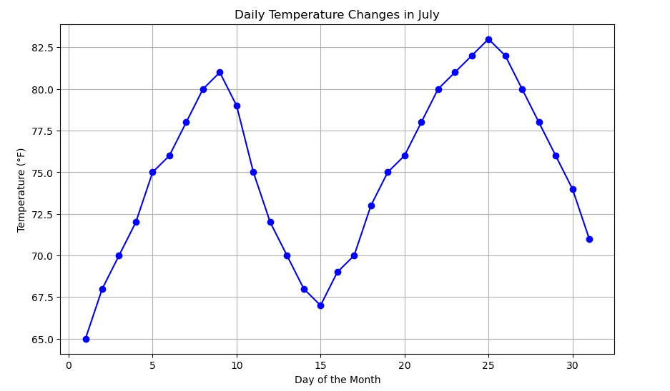

**Conclusion:**

* **The visualization indicates a clear cyclic temperature pattern in July.**
* **Peaks are observed around days 10 and 25, with the highest temperature at 83°F.**
* **The lowest temperatures occur at the start (65°F) and around day 15, suggesting natural warming and cooling phases.**
* **Such patterns may be influenced by local weather dynamics or seasonal trends.**

**Lab2: Create a line plot to visualize the daily closing prices of a stock over a year and give your conclusion.**

**Input: days = list(range(1, 78)) # Daily closing prices of a stock (replace with your own data)**

**stock_prices = [100, 105, 110, 115, 112, 120, 118, 125, 128, 130, 132, 135, 138, 140, 142, 144, 145, 148, 150, 155, 160, 158, 162, 165, 170, 172, 175, 178, 180, 182, 185, 188, 190, 192, 195, 198, 200, 198, 195, 193, 190, 188, 185, 182, 180, 178, 175, 172, 170, 168, 165, 162, 160, 158, 155, 152, 150, 148, 145, 143, 140, 138, 135, 132, 130, 128, 125, 123, 120, 118, 115, 112, 110, 108, 105, 103, 100]**

**Code:**

**import matplotlib.pyplot as plt**

**# Input data**

**days = list(range(1, 78))**

**stock_prices = [**

**100, 105, 110, 115, 112, 120, 118, 125, 128, 130, 132, 135,**

**138, 140, 142, 144, 145, 148, 150, 155, 160, 158, 162, 165,**

**170, 172, 175, 178, 180, 182, 185, 188, 190, 192, 195, 198,**

**200, 198, 195, 193, 190, 188, 185, 182, 180, 178, 175, 172,**

**170, 168, 165, 162, 160, 158, 155, 152, 150, 148, 145, 143,**

**140, 138, 135, 132, 130, 128, 125, 123, 120, 118, 115, 112,**

**110, 108, 105, 103, 100**

**]**

**# Create the plot**

**plt.figure(figsize=(10, 6))**

**plt.plot(days, stock_prices, marker='o', linestyle='-', color='b')**

**# Add labels and title**

**plt.title("Stock Prices Over a Year")**

**plt.xlabel("Day of the Year")**

**plt.ylabel("Stock Price (USD)")**

**plt.grid(True)**

**# Show the plot**

**plt.show()**

**Output:**

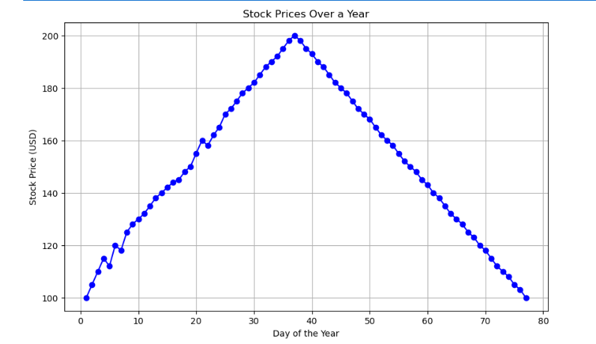

**Conclusion:**

* **Price Increase: From day 1 to approximately day 38, the stock price steadily increases, peaking at $200.**
* **Price Decline: After day 38, the price steadily declines, returning to its initial value of $100 by day 77.**

**Lab3: Create a bar chart to represent monthly expenses in different spending categories and give your conclusion.**

**Input: categories = ['Rent', 'Groceries', 'Utilities', 'Entertainment', 'Transportation'] # Monthly expenses in dollars (replace with your own data)**

**expenses = [1200, 400, 200, 150, 250]**

**Code:**

**import matplotlib.pyplot as plt**

**# Input data**

**categories = ['Rent', 'Groceries', 'Utilities', 'Entertainment', 'Transportation']**

**expenses = [1200, 400, 200, 150, 250]**

**# Create the bar chart**

**plt.figure(figsize=(8, 6))**

**plt.bar(categories, expenses, color='skyblue')**

**# Add labels and title**

**plt.title("Monthly Expenses by Category")**

**plt.xlabel("Spending Categories")**

**plt.ylabel("Expenses (USD)")**

**plt.grid(axis='y', linestyle='--', alpha=0.7)**

**# Show the chart**

**plt.show()**

**Output:**

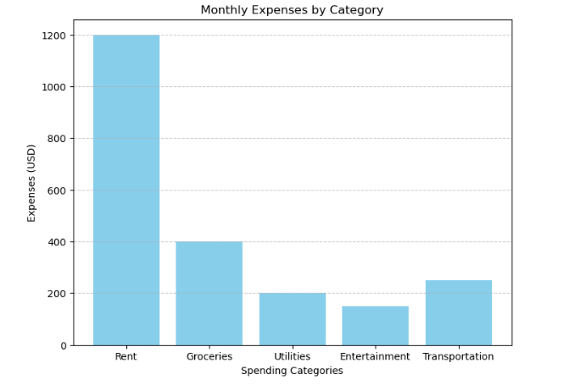

**Conclusion:**

* **Largest Expense: Rent is the highest expense at $1200, which dominates the monthly budget.**
* **Moderate Expenses: Groceries and Transportation contribute $400 and $250 respectively.**
* **Lowest Expenses: Utilities and Entertainment account for $200 and $150, making up the smallest portions.**

**Lab4: Create a histogram to represent the distribution of product prices in a retail store and give your conclusion.**

**Input: product_prices = [24.99, 34.99, 49.99, 64.99, 39.99, 54.99, 79.99, 99.99, 29.99, 44.99, 59.99, 69.99, 84.99, 109.99, 119.99, 89.99, 74.99, 124.99, 69.99, 54.99]**

**Code:**

**import matplotlib.pyplot as plt**

**# Product prices**

**product_prices = [**

**24.99, 34.99, 49.99, 64.99, 39.99, 54.99, 79.99, 99.99, 29.99, 44.99,**

**59.99, 69.99, 84.99, 109.99, 119.99, 89.99, 74.99, 124.99, 69.99, 54.99**

**]**

**# Create the histogram**

**plt.hist(product_prices, bins=8, edgecolor='black')**

**plt.title('Distribution of Product Prices in a Retail Store')**

**plt.xlabel('Product Prices (USD)')**

**plt.ylabel('Number of Products')**

**# Show the histogram**

**plt.show()**

**Output:**

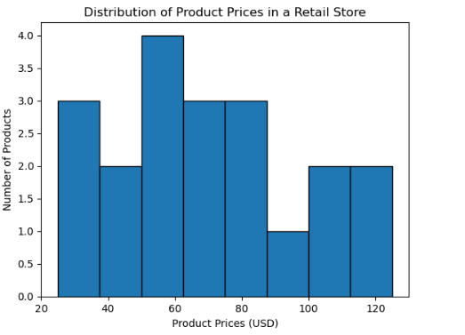

**Conclusion:**

* **The product prices are distributed across various ranges, with most prices concentrated in the mid-range ($60-$80).**
* **There are relatively fewer products in the higher price range ($100-$140).**
* **The distribution suggests that the store targets customers who prefer moderately priced products, while also catering to those seeking both budget-friendly and premium options.**